
ALDO J. LEAL AND JOSE L. LOPEZ
Hararghe Catholic Secretariat: a miracle in the middle of the Ethiopian Dessert
It was a warm Friday morning when we traveled on our third field visit in a region near Dire Dawa, Ethiopia. As MBA, Law and Peace Studies students at the University of Notre Dame, we were selected to participate in the Business on the Frontlines program. In this course, students have had the opportunity to serve different international organizations in countries trying to rebuild their economies after war or violent conflict. Our project focused on assisting Hararghe Catholic Secretariat (HCS), an NGO involved in the implementation of humanitarian, emergency and long term development programs in Ethiopia. That day, we were traveling to several small towns were HCS has been helping build wells and training farmers to transform pieces of land in the middle of the desert into oases. We had the opportunity to talk with one of the beneficiaries who told us the incredible story about how the work carried out by HCS had changed his life.
Bekele is a 41 year-old farmer who has four sons and three daughters. Agriculture has been his household’s major source of income; his family owns 1/2 ha of land that they use for crop production. By 2005, his land had degraded to such degree (due to soil erosion) that his family had to survive with a meager crop production of about 50 kg of maize. The sale of maize resulted in a small income of about US$17 per year. Since the proceeds from the crop were not sufficient to feed his household, Bekele, as many Ethiopians in the region do, traveled to the nearest city to work as a daily laborer where he earned US$8.5 per month. Since his household could barely feed itself for 5 months, Bekele’s brothers supported him with some food for his children.
This is when HCS appeared in his life. Since Bekele’s household income fell into the poor/very poor category, his family was selected to be a beneficiary of the Productive Safety Net Program (PSNP) led by HCS. PSNP is a safety-net mechanism to help vulnerable people absorb catastrophic shocks of drought and flood. Initially, 6 months’ worth of food was made available to the household in exchange for participation in public work. Between 2006 and 2009, his household received 630 kg of wheat, 18.9 kg of cooking oil and 63 kg of pulses every year; the food received was worth an estimated $US207.
In addition to providing food aid, HCS helped Bekele cultivate a special type of bush, which produces fresh young leaves that are chewed as bubble gum. Chewing the bush is an age-old tradition that takes place in weddings (“nikah”), in mourning, in rituals, in religious ceremonies, and in everyday life. Since this bush requires small amounts of water and does not degrade the soil, the small plot owned by the household recovered its soil fertility and increased its productivity. He stopped working as a wage laborer and focused on crop management, which resulted in increased yield. Bekele was able to produce between 400 and 500 kg of the bush per year in his piece of land, ten times more than the maize produced from the degraded land. He was able to earn between US$2,300 to US$2,900 per year.

The donor world and CRS’ role
Ethiopia is one of the poorest countries in the world, with 39% of its population living on under $1.25 USD a day. The country has also experienced a long standing trade deficit that, aside from the economic implications, points to the fact the country is not self-sustainable. Exports are almost five times greater than imports, and this trade gap is compensated through aid and debt from outside parties. “The post-2000 period has seen large disbursements of grants and loans from the United States, the European Union, individual European nations, Japan, the People's Republic of China, the World Bank, and the African Development Bank. These funds totaled US$1.6 billion in 2001.”
Within recent years, fewer donors with bigger budgets and specific plans for the countries they plan to positively affect have emerged as sources of support for HCS. These donors include the Bill and Melinda Gates Foundation, which has funded in excess of $26 Billion Dollars from 1994 to present and USAID, with a budget of $15 billion in 2011.
Catholic Relief Services (CRS) often acts as a partner, making the connection between those big donors and the executing organizations in the ground.
CRS stays up to date with the donor world and their strategic plans in order to know which grants and opportunities are aligned with its own programs in country. Once it finds an opportunity that makes strategic sense, they go after them in conjunction with local partners. Once the funds are approved, CRS implements with the partner and/or supervises the partner as they execute the programs.

Partners’ role and HCS
CRS has a presence in six regions: Africa, Asia, Europa, Latin America and the Caribbean, Middle East and North Africa and the United States. It serves forty countries in Africa alone.
In order to serve those most in need, CRS partners with local organizations or international organizations that have a local presence and/or the capacity to provide aid.
Because CRS is the party seeking grants in the US, it has to report back to the donor on a periodic basis and show effectiveness and transparency to maintain the relationship. When CRS establishes a relationship with a local implementing partner, it needs to make sure money will be well spent and the donor’s mission is kept at heart; money cannot be spent on projects the donor did not approve.

How HCS Operates on the Ground
HCS has been involved in a range of emergency, rehabilitation and development programs in different communities in East Ethiopia. Its three major assistance programs include the following:
a) Food security: an immediate cause of food insecurity in the Eastern part of Ethiopia is the low agricultural productivity caused by drought and flood. HCS helps farmers by providing crop seeds that are selected based on market demand and profitability. Also, Agricultural Engineers provide technical capacity-building activities through diverse workshops that improve the technical and marketing skills of the farmers.

b) Social services & welfare: the increase in the number of orphans and vulnerable children in Ethiopia is a major concern in Ethiopia. A UNICEF study estimates the number of street children in Ethiopia to be up to 185,000 in 2010. HCS provides educational support, health services, and practical skills training to hundreds of orphans in the Hararghe region.

c) Water and sanitation: Under this program, several physical structures have been constructed from different sources. The main activities include: spring development, roof rain water harvesting, borehole development, hand dug well, small scale irrigation systems, wash basins and shower rooms.

The importance of Agriculture in Ethiopia
Agriculture is an important component of Ethiopia’s economy, with an estimated 48% of the 30 Billion Total GDP generated in 2010 coming from this sector. Exports are dominated by agricultural products (83.9% of exports) and more than 80% of the population depends on various forms of agricultural production for their livelihood (82% of the 83 Million people in Ethiopia live in rural areas). Ethiopia is one of the countries with more agricultural potential in the horn of Africa since it possesses vast areas of fertile land, diverse climate, generally adequate rainfall, and a large labor pool. However, because of drought, which has repeatedly affected the country since the early 1970s, a poor economic base (low productivity, weak infrastructure, and low level of technology), and overpopulation, the agricultural sector in Ethiopia has historically underperformed. This low growth rate in agricultural production is the main cause of the food insecurity that affects 4.6 million people in Ethiopia. Most agricultural producers in Ethiopia are subsistence farmers with small holdings, often broken into several plots. According to the Central Statistical Agency (CSA), in 2008 the average Ethiopian farmer holds 1.2 hectares of land, with 55.13% of them holding less than 1.0 hectare.

The most important cash crop in Ethiopia is coffee. Approximately 25% of Ethiopia's population depends directly or indirectly on coffee for its livelihood. The export of coffee allows the country to secure much needed foreign currency that can be used for imports or debt payments. Ethiopia’s reserves stand at $1.78 billion dollars (according to the World Bank) which is barely enough for 2 months of imports (too low). It should come as no surprise that farmers have been encouraged to produce the bean. Many initiatives and aid funds have been directed at improving and growing exports of coffee and even though it has been successful for periods of time, variability of prices has often hurt farmers.

Ethiopia and Foreign Trade
Why does the country not leverage its resources to export more?
In addition to being landlocked, Ethiopia is in a “bad neighborhood”; its neighbor to the East is Somalia, which has had no central government since 1991 and been in the spotlight due to Somali ‘pirates’. To the West, Ethiopia shares its border with Sudan and South Sudan, which remain engaged in actual military confrontation after South Sudan’s secession. Ethiopia faces further threats from its neighbor in the North, Eritrea. The two countries have conflicted for thirty some years and have loosely defined borders.

The Miraculous Plant

With the annual income produced by the cultivation of the bush, the Bekele family had enough resources to invest in other economic activities. For instance, Ms. Bekele saved US$35 to buy three baby goats to fatten and sell. In the third year, her annual profit for buying and selling goats and cattle was US$150. Moreover, this improvement in their income generated enough cash to afford more sophisticated consumer goods, like the satellite dish they got in 2009. In 2010, Bekele’s family had enough money to buy its first car, a good that only farmers in this region can afford.
Whenever farmers experience a substantial economic improvement in East Ethiopia, they are quick to point out that it is due to the bush. However, there is no such thing as a free lunch. This bush has affected the health, personality, finance and generally the social life of thousands of Ethiopians. This bush is actually a mild narcotic called khat that contains cathinone, an amphetamine-like stimulant that causes excitement and euphoria. It is widely used for socializing since individuals become very talkative under the influence of the plant. Also, khat chewers feel an increase in alertness and energy together with enhanced depth of perception. This is why professors encourage students to use it to boost their concentration to study for exams. However, the uplifting effects only last 1.5 - 3.5 hours, and can be followed by mild dysphasia, anxiety, reactive depression, insomnia, loss of appetite and in some cases, manic behaviors such as hyperactivity and even psychosis. Long-term use can precipitate the following effects: liver malfunction, permanent tooth darkening, mouth cancer, enlargement of salivary glands and susceptibility to ulcers.
Khat use can strain family incomes and lead to a loss of productivity at work. Consider the case of Bekebeke, an NGO worker we interviewed in Dire Dawa who has been chewing khat for nearly twenty five years. He spends nearly US$85 per month, which is a bit more than 50 % of his monthly salary. He usually chews khat at home with his sons that are 15, 13 and 9 years old and after work with his colleagues. Sometimes, he starts chewing khat with his coworkers in the afternoon and doesn’t go back to work until the following day. The case of Bekebeke is not uncommon since khat affects mainly those who are between the ages of 17 to 40, people who are supposed to be the engines of the Ethiopian economy.
Producers of khat are not exempt of its negative effects. Bekele consumes fresh khat almost every day in the harvesting season since he says it is “free” for him. He mentioned that it helps him with his appetite, so now he spends less money on food for him and his family. His oldest son quit school to work in the Awaday market selling khat every night. He sleeps in the mornings and spends every evening chewing khat with his friends.

Puzzlingly enough, while HCS helps farmers cultivate khat, another Catholic group founded by Mother Teresa of Calcutta, Missionaries of Christ, treats hundreds of people with mental disorders caused by the drug. This organization is facing capacity issues, since in the past years the number of patients that arrive seeking care exceed their current capabilities.

Although khat creates several social disadvantages, discontinuing its production is unlikely since income produced by exporting the bush is increasing as national and international demand rises. It is estimated that worldwide, more than 10 million people chew khat every day. In Ethiopia, Khat is the second largest export commodity after coffee, and a major source of foreign currency. Export quality khat is packed and sent every day to countries that do not ban the plant of which Djibouti and the United Kingdom are the major ones. Although the importation and trade of khat is formally prohibited in Saudi Arabia, the United States, Italy, France and Switzerland, several tons of khat are sent illegally every month hidden within coffee beans. The local market for khat is also great. Every day, fresh khat is transported to the capital and distributed to various areas using trains especially built for khat transportation.

Khat vs. Coffee
What are the profit-generating capabilities of a khat crop?
A hectare of land can yield between 800 and 1,000 kg of khat per year. The plant’s price in the market has been increasing steadily; it traded at an average $5.8/Kg for the 2009/10 period.

For a family that owns 1 hectare of land, this would result in an annual income of between $US 4,640 and $US 5,800. Had the same family planted coffee, they would have seen a yield between 400 and 500 kg. Coffee’s price has varied between 1.7 and 1.88 per kilogram for that same period. The same family would have had an income of between $680 and $940.

Are there any other benefits to growing Khat?

- Coffee plantations are more costly to set up and keep than Khat plantations. Coffee plants need water and shade, Khat thrives in hot weather and does not need much water.
- Production and trade of the Khat has allowed Ethiopian business people to develop relationship with some of their neighbors, including Kenyans and Somalis who come to the market in Dire Dawa to purchase, package and ship the product, all while leveraging the port of Djibouti.
- Khat brings in more foreign currency that coffee does and that not only benefit the growers but the country as a whole, that can see its international reserves go up.
The Bottom Line
One good way of comparing is by setting a baseline; that baseline is the poverty line defined by the United Nations which is $1.25 per person per day (for Ethiopia).
For the year 2009, a member of one of these rural families (a family of five) growing Khat would have had a daily income of $2.9, well above the $1.25. A member of a family growing coffee would have had a daily income of $0.424.
If one’s livelihood depends solely on crop yield from their land, the choice between growing khat verses coffee may determine if they live in poverty.

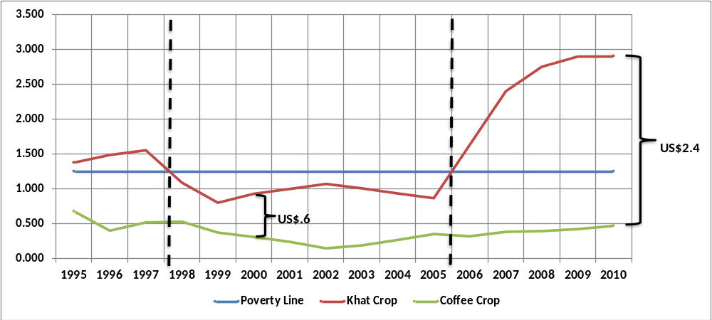

In the graph: The Y axis is income per person per day in US Dollars. Variations are explained by the changes in coffee and Khat prices for growers in Ethiopia.
What should CRS do?
CRS has several partners in Ethiopia (the biggest CRS program in the world), but HCS is its key partner. The success of future CRS initiatives is largely dependent on its relationship with HCS. Through one of the visits to the Harerge region, where HCS operates, CRS Ethiopia discovered that many of the villages that have received aid are growing Khat.
Should CRS call HCS to prohibit farmers receiving aid from the organization from growing Khat? Can CRS and HCS help the farmers if there is no other crop that can generate the same kind of income? How to offset the nation’s current need for foreign currency?

